Class: TYIT(NEP) Sem: V Roll No.: TYIT36 Date: 10/07/26 Course Name: Next Generation Technologies Page no:
Practical Number: - 1

Aim: Implement query on MongoDB Basics.
- What is MongoDB?
MongoDB is a NoSQL, document-oriented database that stores data in JSON-like (BSON) documents instead of tables and rows. It provides high performance, scalability, and flexibility for handling large amounts of data.
- What is MongoDB Compass?
MongoDB Compass is the official graphical user interface (GUI) for MongoDB that allows users to visually explore, query, and manage database data without using command-line commands.
- What is MongoDB Shell?
MongoDB Shell (mongosh) is the command-line interface used to interact with MongoDB databases by executing JavaScript commands for database operations and queries.

- MongoDB Basic Commands:-

  - show dbs
Definition: Displays the list of all databases available in the MongoDB server. It is used to view the existing databases.
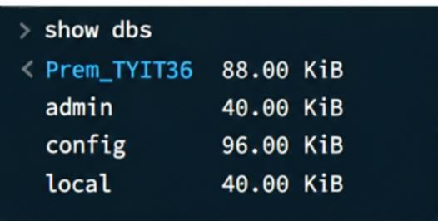

  - db
Definition: Displays the name of the currently selected database. It is used to confirm the current database context.
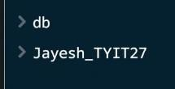

  - use database_name
Definition: Switches to the specified database or creates it if it does not exist. It sets the current database for performing operations.
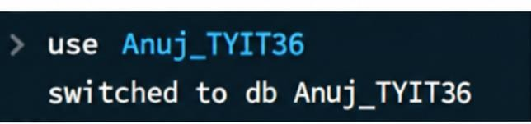

  - db.createcollection(Collection_name)
Definition: Creates a new collection in the current database before inserting documents.

Class: TYIT(NEP) Sem: V Roll No.: TYIT36 Date: 10/07/26 Course Name: Next Generation Technologies Page no:
Practical Number: - 1

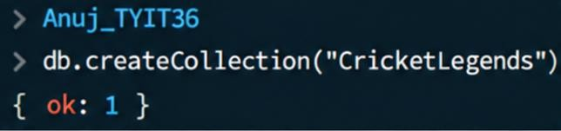
It is used to explicitly create a collection.
  - show collections
Definition:Displays the list of all collections in the current database. It helps verify the available collections.


  - db.collection_name.insertone({id:1,name:” ”})
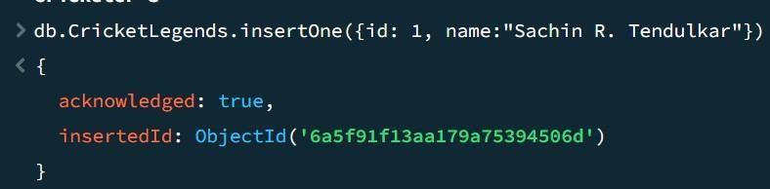
Definition: Inserts a single document into the specified collection. The document is stored in JSON format in the collection.

  - db.collection_name.insertMany( [{id:1,name:” ”},{id:2,name:” ”},{id:3,name:” ”}] ) Definition: Inserts multiple documents into a collection in a single operation. It is used to add many records efficiently
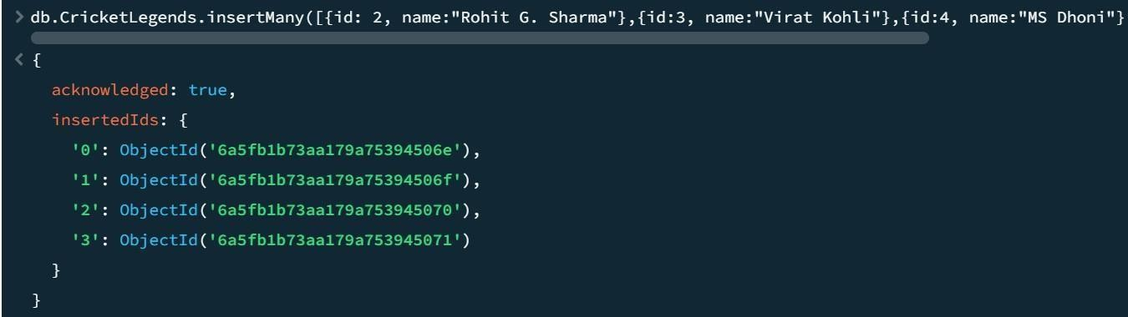

  - db.collection_name.Find()
Definition: Displays all the documents stored in the specified collection. It is used to retrieve and read data from the database.

Class: TYIT(NEP) Sem: V Roll No.: TYIT36 Date: 10/07/26 Course Name: Next Generation Technologies Page no:
Practical Number: - 1
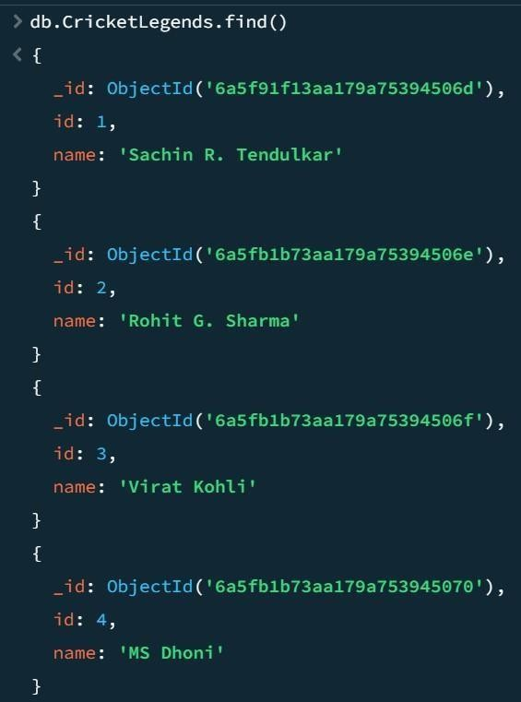
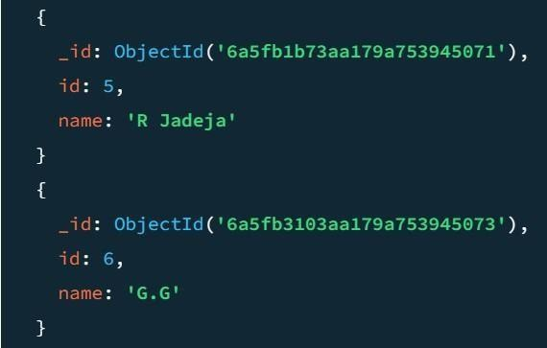

  - db.collection_name.deleteone({ _id: objectId(‘ object_id’)})
Definition: Deletes a single document that matches the specified condition. It is used to remove a particular record from the collection.

Class: TYIT(NEP) Sem: V Roll No.: TYIT36 Date: 10/07/26 Course Name: Next Generation Technologies Page no:
Practical Number: - 1
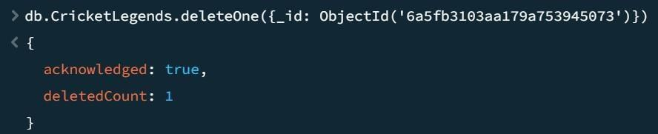
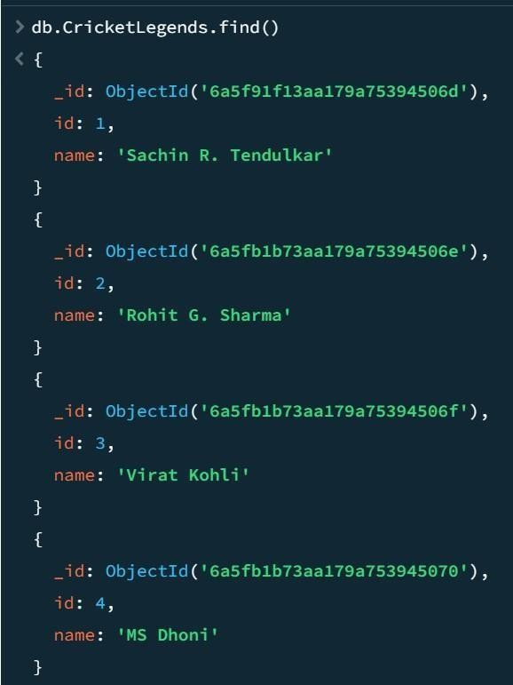
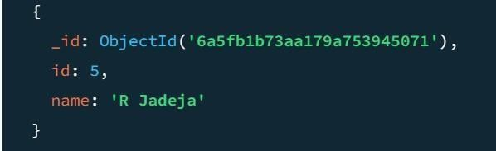
  - db.collection_name.Find().Pretty()
Definition: Displays the retrieved documents in a well-formatted and readable structure. It makes the output easier to understand.

Class: TYIT(NEP) Sem: V Roll No.: TYIT36 Date: 10/07/26 Course Name: Next Generation Technologies Page no:
Practical Number: - 1
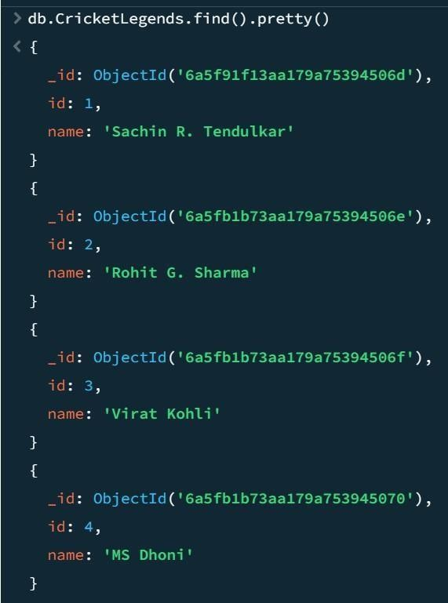

  - db.collection_name.drop()
Definition: Deletes the specified collection from the current database. It removes the collection along with all its documents.
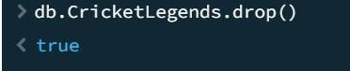

  - db.dropdatabase
Definition: Deletes the currently selected database permanently. It removes the database along with all its collections.
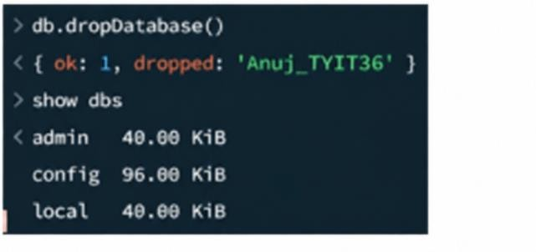

Class: TYIT Sem: V Roll No.: TYIT36 Date:23/07/2026 Course Name: NGT Page no:
Practical Number: - 02
AIM: Implement simple queries with MongoDB. Database Name: Anuj
Collection Name: Employee_TYIT36 Dummy Records:

Queries:
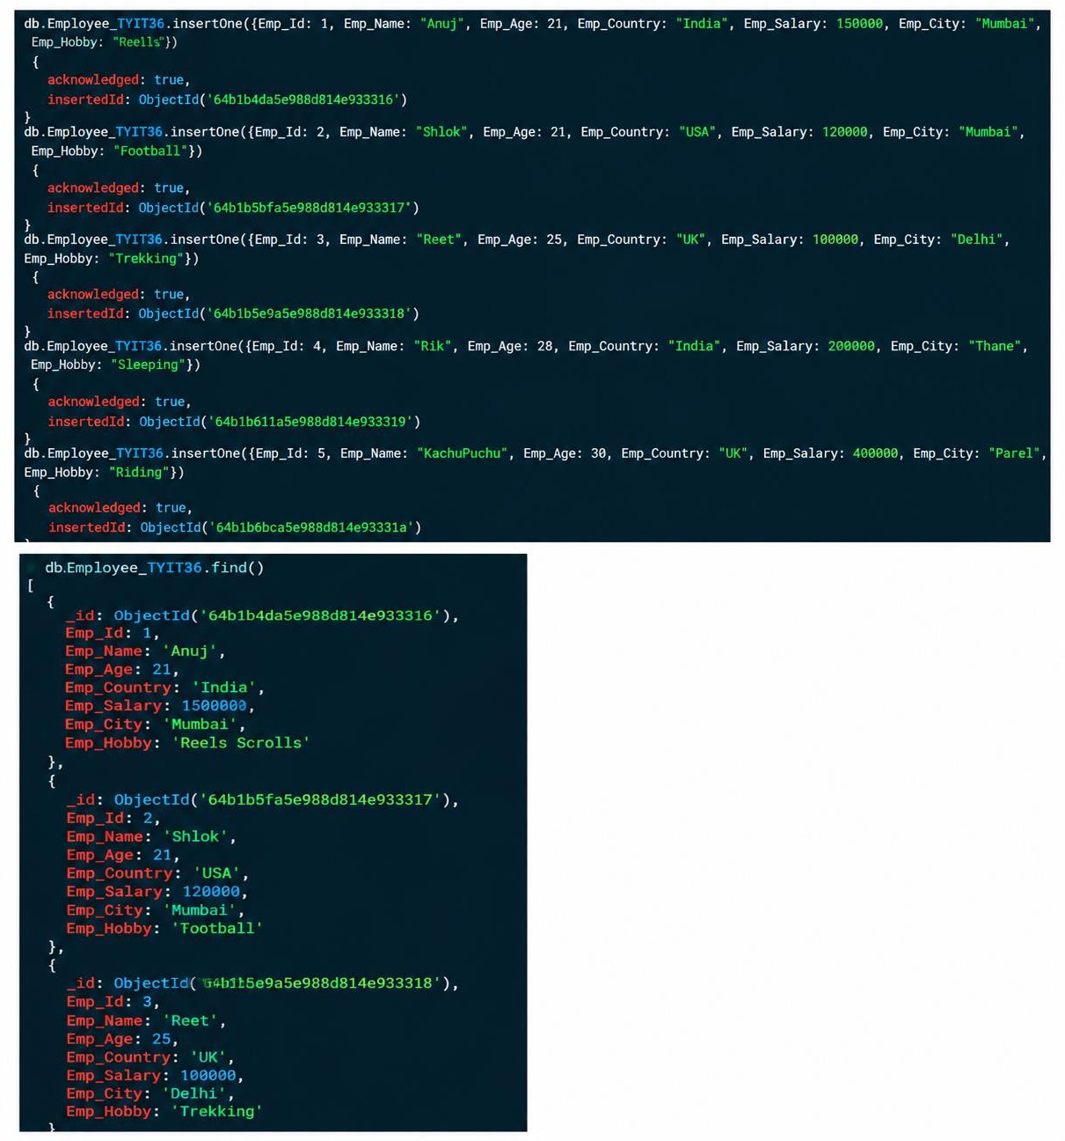

Class: TYIT Sem: V Roll No.: TYIT36 Date:23/07/2026 Course Name: NGT Page no:
Practical Number: - 02

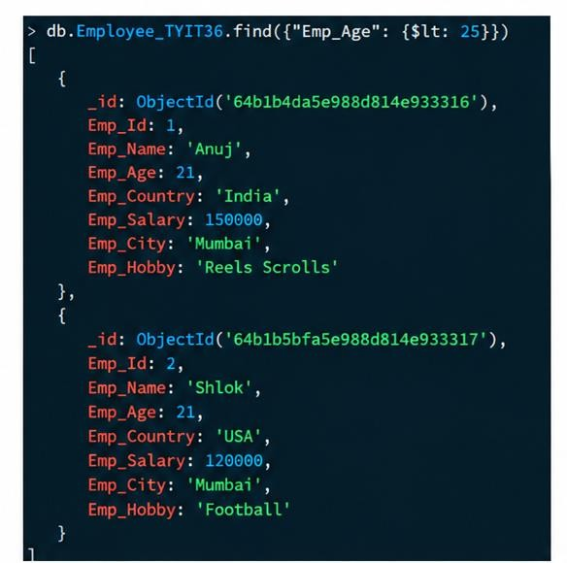
- $lt: It returns the record that are below than a given value. It works with number only.
- $lte: It returns the record that are less than or equal to a given value. It works with number only.
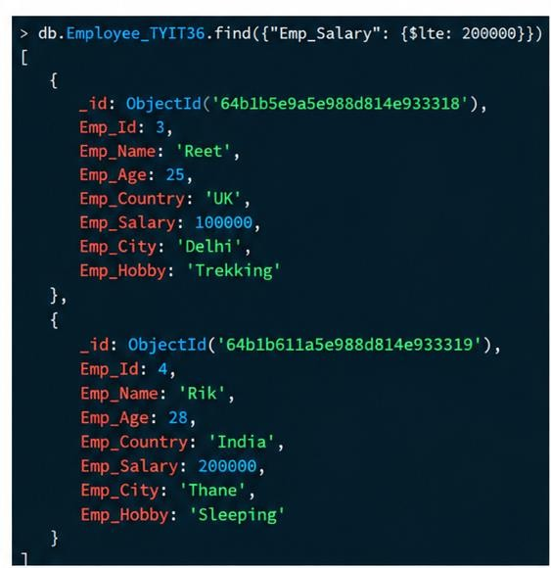
- $gt: It returns the record that are greater than a given value. It works with number only.

Class: TYIT Sem: V Roll No.: TYIT36 Date:23/07/2026 Course Name: NGT Page no:
Practical Number: - 02
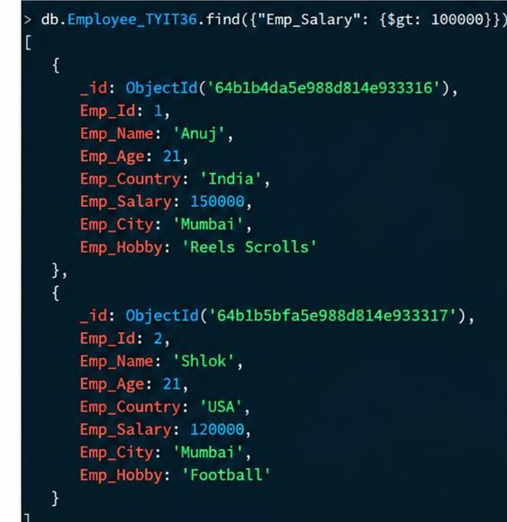

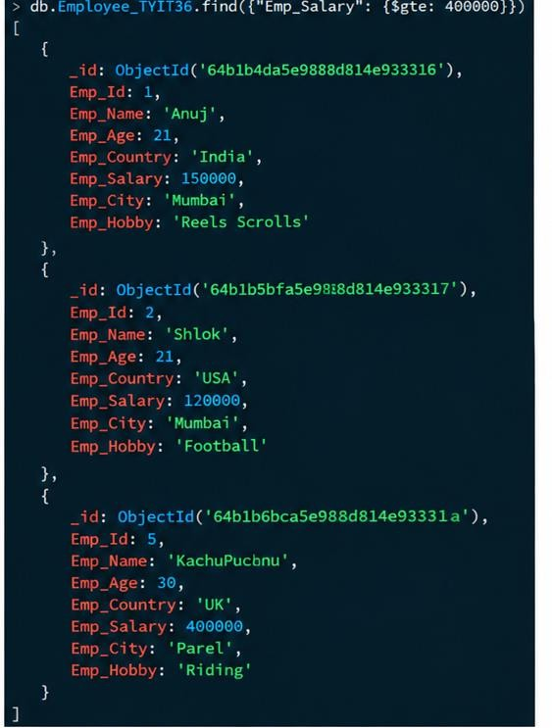
- $gte: It returns the record that are greater than or equal to a given value. It works with number only.
- $in: It returns the record that matches a given String value.

Class: TYIT Sem: V Roll No.: TYIT36 Date:23/07/2026 Course Name: NGT Page no:
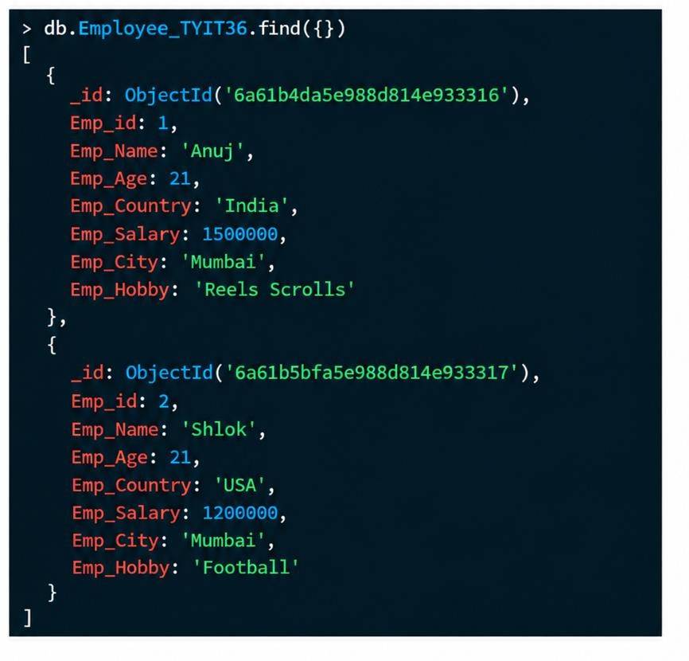
Practical Number: - 02

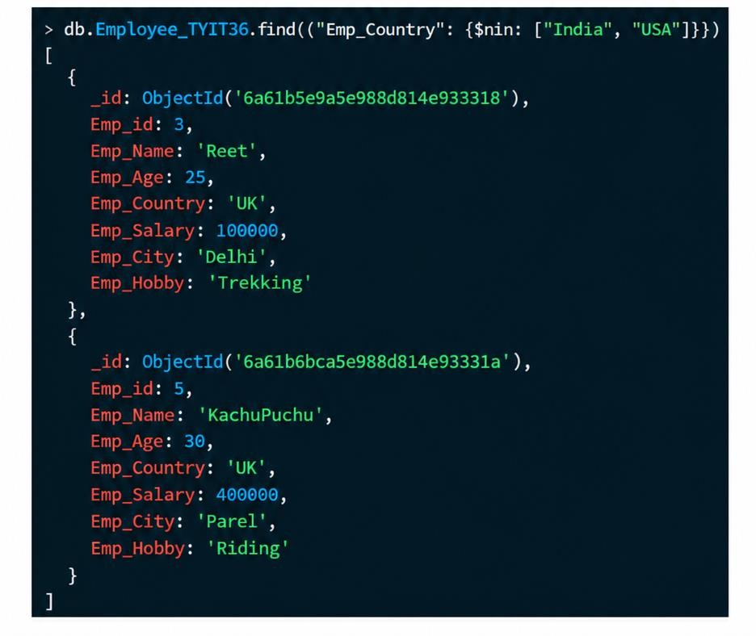
- $nin: It returns the record that do not matches a given String value.

CLASS:TYIT SEM:V ROLLNO.:TYIT36 DATE:05/08/26
COURSE NAME: NGT PAGENO.:
PRACTICAL NUMBER: 03
AIM: Implement Aggregate Function with MongoDB. Database Name: Practical3
Collection Name: Employee_TYIT36
Dummy Records:
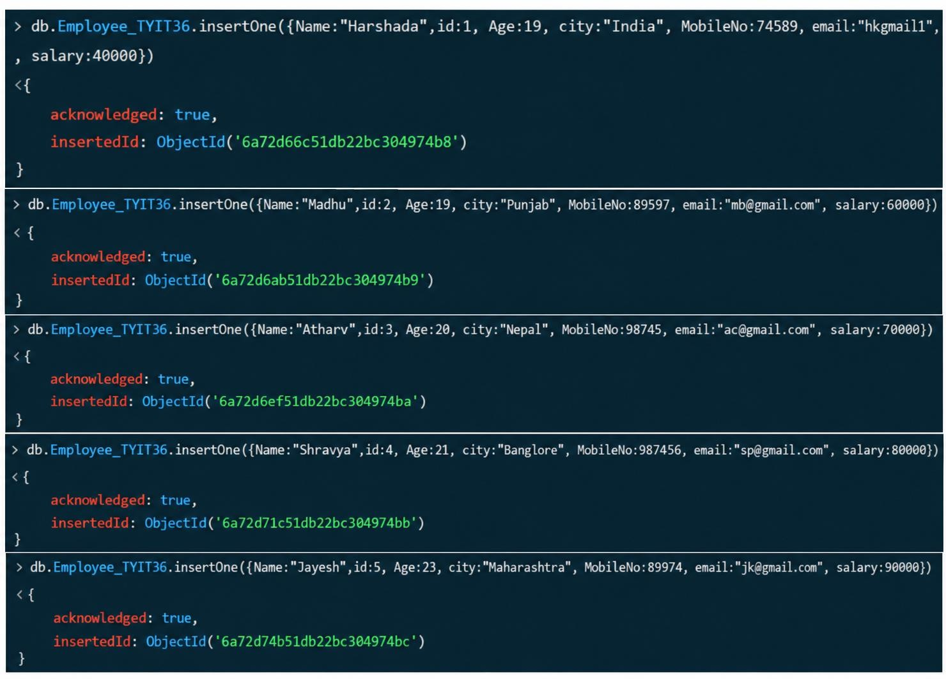

CLASS:TYIT SEM:V ROLLNO.:TYIT36 DATE:05/08/26
COURSE NAME: NGT PAGENO.:
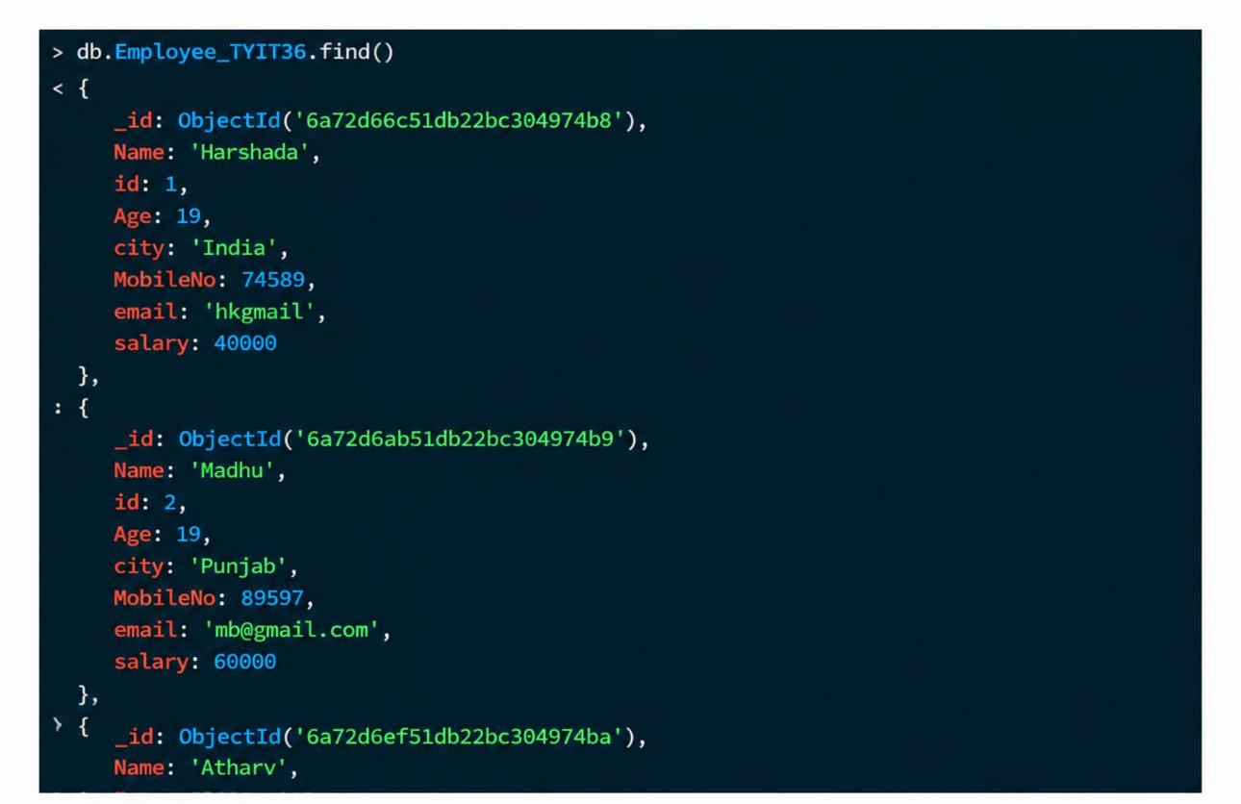
PRACTICAL NUMBER: 03

AGGREGATE FUNCTIONS:
- $max: Returns the highest (maximum) value from a collection of documents. It is mainly used in the
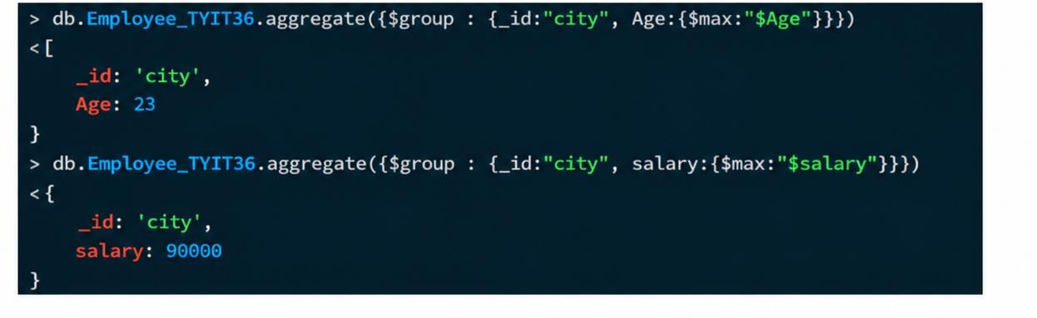
$group stage of MongoDB aggregation.

- $min: Returns the lowest (minimum) value from a collection of documents. It is mainly used in the
$group stage of MongoDB aggregation.

CLASS:TYIT SEM:V ROLLNO.:TYIT36 DATE:05/08/26
COURSE NAME: NGT PAGENO.:
PRACTICAL NUMBER: 03
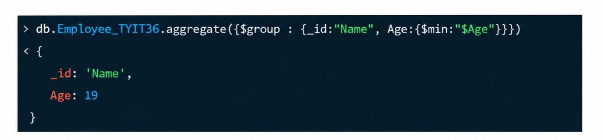

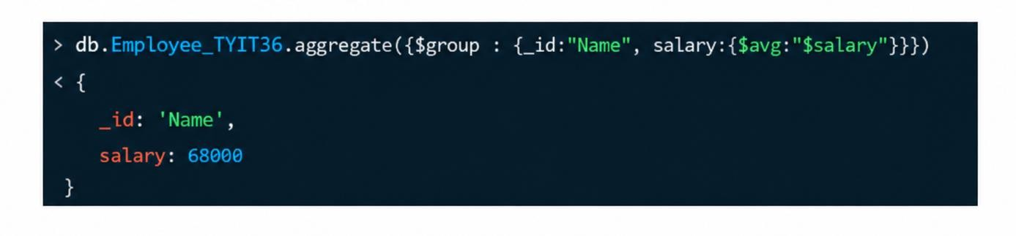
- $avg: Returns the average value of a specified field from a collection of documents. It is mainly used in the $group stage of MongoDB aggregation.
- $sum: Returns the total (sum) value of a specified field from a collection of documents. It is mainly used in the $group stage of MongoDB aggregation.
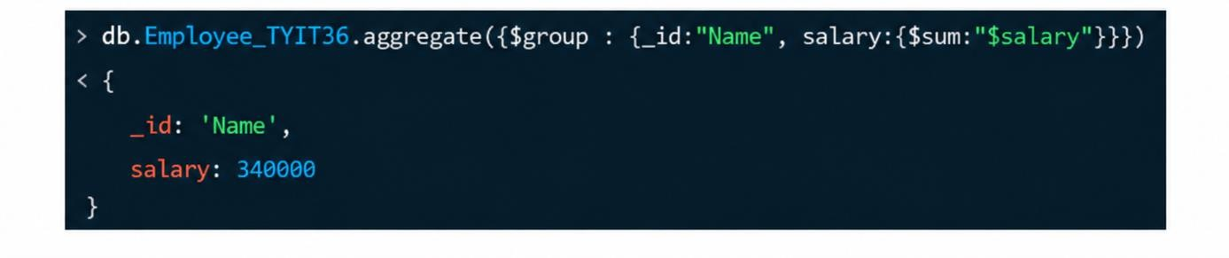

Class: TYIT | Sem: V | Roll No.: TYIT36 | Date : 12-08-26
Course Name: NGT |  |  | Page no:
Practical Number:- 4

AIM: Implement replication, backup and restore.

- DOWNLOAD MongoDB Command Line Database Tools STEPS:
  - Go to chrome and type MongoDB Command Line Database Tools.
  - Then click on the first website and you will see where to download it.
  - Select package as msi and then download it.
  - After downloading , go to file then go the following files:
  - Local disk(c)>Program files>Mongodb>Tools>100>bin
  - After this create a backup named folder inside the bin.
- Go to Mongodb :
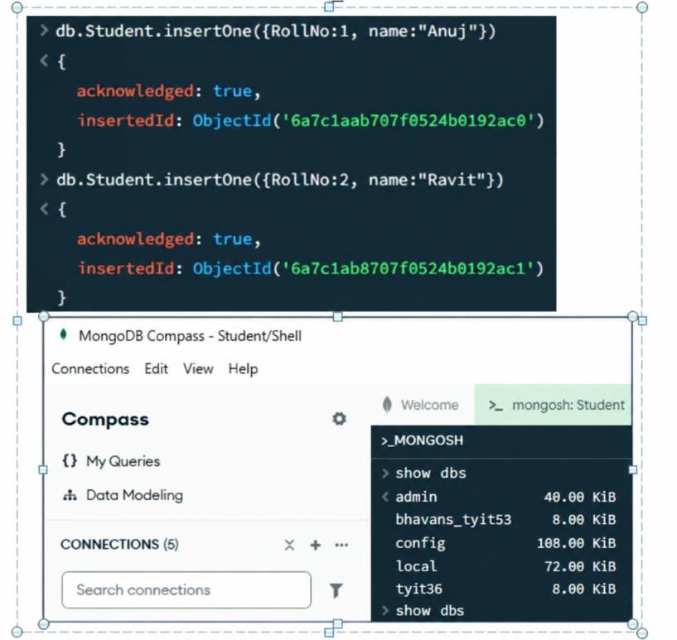
Database Name:TYBSCIT_36 Collection Name: Student_TYIT36

Class: TYIT | Sem: V | Roll No.: TYIT36 | Date : 12-08-26
Course Name: NGT |  |  | Page no:
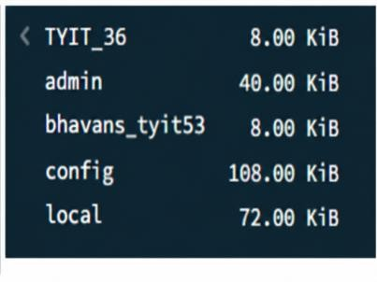
Practical Number:- 4

COMMAND IN CMD:
- mongodump --db TYBSCIT_36 --out \backup - creates a backup of the TYBSCIT_36 MongoDB database.
The backup files are saved in the \backup directory.
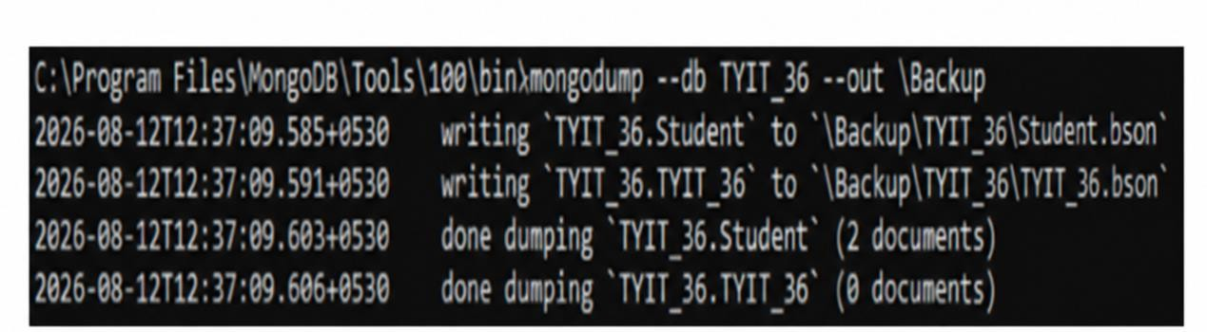
- After this drop the database from mongodb and write this in cmd to check whether the database has been restored.
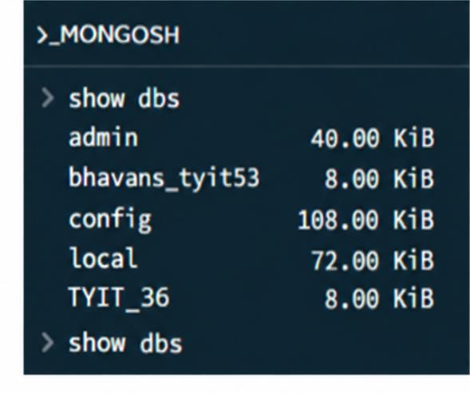

- mongorestore --db TYBSCIT_36 \backup\TYBSCIT_36\Student_TYIT36.bson - restores the Student_TYIT36 collection into the TYBSCIT_36 database.
It takes the backup data from the specified .bson file and imports it into MongoDB.
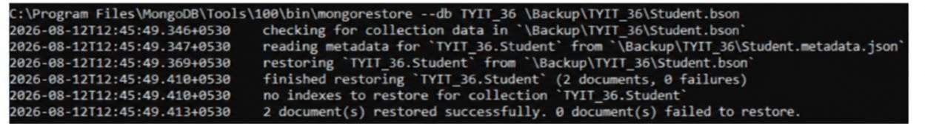
- After restoring the database.

CLASS:TYIT SEM:V ROLL NO.:TYIT36 DATE:11/09/26 COURSE NAME: NGT PAGE NO.:
PRACTICAL NO.: 5
AIM: Implement Java and MongoDB. CODE:
package TYIT36pract5; import org.bson.Document;
import com.mongodb.client.MongoClient; import com.mongodb.client.MongoClients; import com.mongodb.client.MongoDatabase; import com.mongodb.client.MongoIterable; public class TYIT36pract5
{
public static void main(String[] args)
{
String u = "mongodb://localhost:27017/"; MongoClient mongoclient = MongoClients.create(u);
MongoDatabase database = mongoclient.getDatabase("admin"); System.out.println("Connected to MongoDB!!");
MongoIterable<String> databaseNames = mongoclient.listDatabaseNames(); for(String dbName : databaseNames)
{
System.out.println("Database Name: "+ dbName);
}
mongoclient.close();
}
}
OUTPUT:
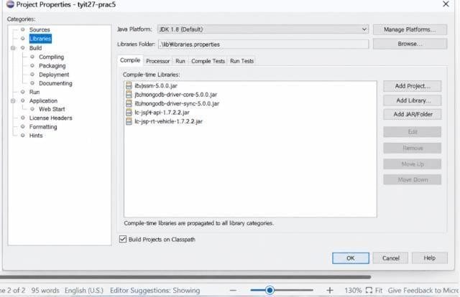
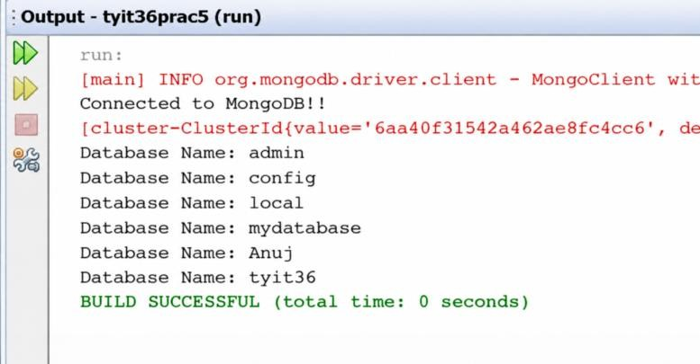

CLASS:TYIT SEM:V ROLL NO.:TYIT36 DATE:11/09/26 COURSE NAME: NGT PAGE NO.:
PRACTICAL NO.: 5

Class: TYIT(NEP) Sem: V Roll No.: TYIT36 Date: 24/09/2026
Course Name: NGT Page no:
Practical Number: -06
Practical aim: - Implement php and MongoDB.

Steps:
- Go to chrome and search Download XAMPP for windows then click on this https://www.apachefriends.org/download.html link and go for this 8.0.30 / PHP
8.0.30 version to download.
- Once the XAMPP is downloaded open it and start the apache and MySql.
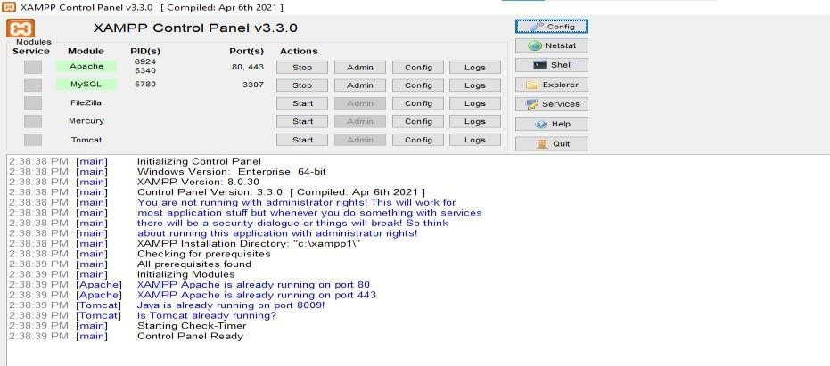
- Download MongoDB php extension to establish the communication between XAMPP and MongoDB, go to chrome and search pecl php mongoBD and click on this first link https://pecl.php.net/package/mongodb .
  - After clicking on this link search for the version 1.13.0 and click on DLL and this will direct you on a page where you will find dll list .
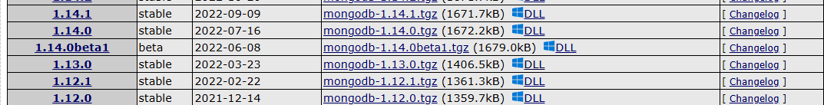

Class: TYIT(NEP) Sem: V Roll No.: TYIT36 Date: 24/09/2026
Course Name: NGT Page no:
Practical Number: -06
  - In that list click on 8.0 Thread Safe (TS) x64 where there is php 8.0 version column.
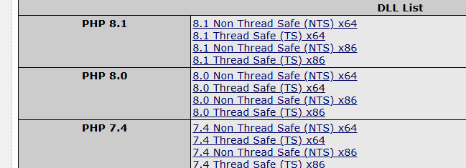
  - The zip file will be downloaded. Then extract all those files and click on the extracted folder and copy the php_mongo.dll.
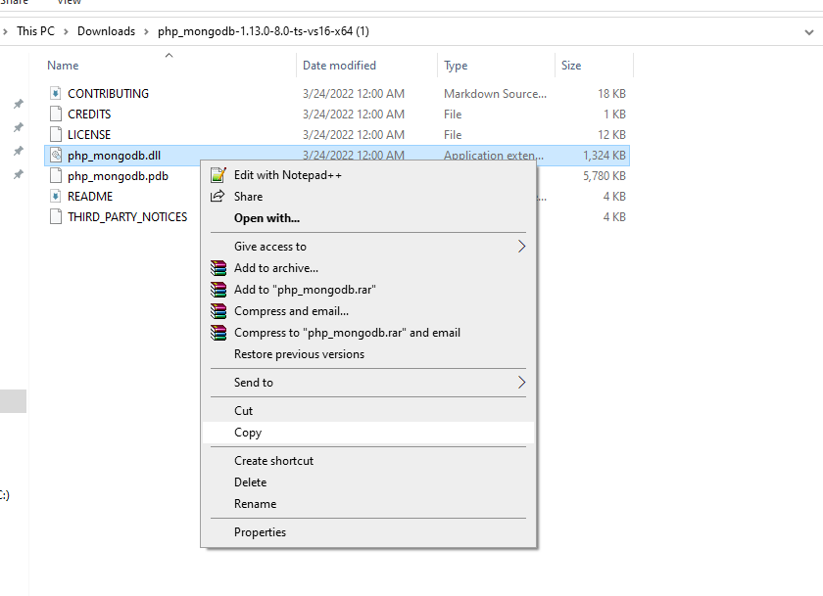

- After it is copied paste it in the xamp folder in the C drive.
- Then go back to your XAMPP and right click on the apache’s config button and select
php(php.ini).
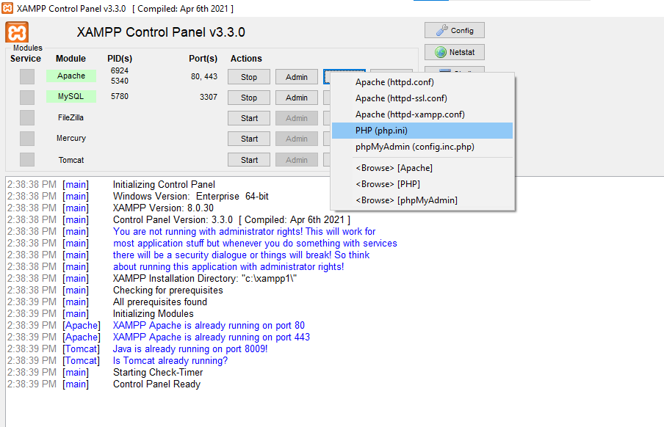
- The press control+f to find extension=php_ftp.dll and after finding it add a line below this php_mongodb.dll.

Class: TYIT(NEP) Sem: V Roll No.: TYIT36 Date: 24/09/2026
Course Name: NGT Page no:
Practical Number: -06

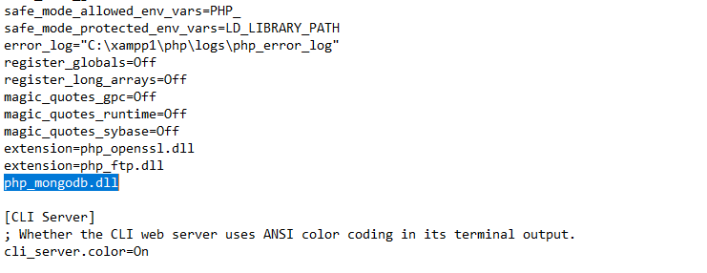

- Once it done go to chrome and search localhost and in the search suggestion window there will be something like localhost/index.php just click on it, and you will get your output.

Final Output:

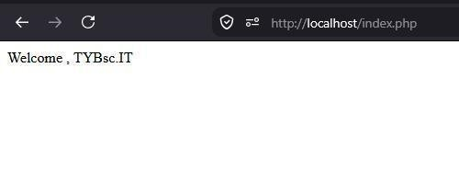

CLASS:TYIT SEM:V ROLL NO.:TYIT36 DATE:11/09/26 COURSE NAME: NGT PAGE NO.:
PRACTICAL NO.: 07
AIM: Implement Python and MongoDB. CODE:
import pymongo
myclient = pymongo.MongoClient("mongodb://127.0.0.1:27017/") mydb = myclient["AnujTYIT36"] print(myclient.list_database_names()) db=myclient['AnujTYIT36']
coll = db["tyi27"]
data = [{"_id":"1","name":"Anuj","age":"22","city":"surat"},
{"_id":"2","name":"Ravit","age":"24","city":"Mumbai"},
{"_id":"3","name":"Atharv","age":"20","city":"Varanasi"},
{"_id":"4","name":" Madhu ","age":"20","city":"Kanpur"},
{"_id":"5","name":"Harshda","age":"19","city":"Pune"}] res = coll.insert_many(data) print("Data inserted") print(res.inserted_ids)
print("First record of the collection:") print(coll.find_one()) print("Record whose id is 3: ") print(coll.find_one({"_id":"5"})) OUTPUT:
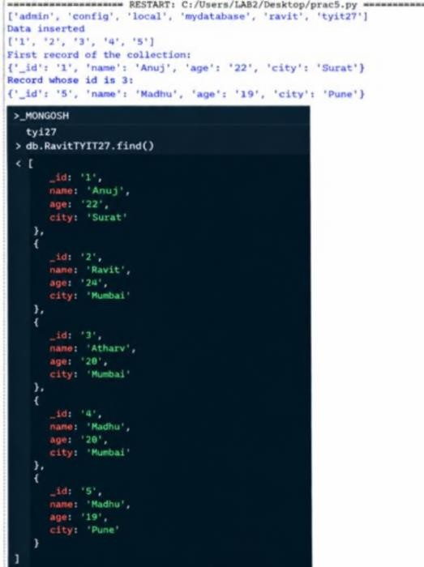

:CLASS:TYIT SEM:V ROLL NO.:TYIT36 DATE:11/09/26 COURSE NAME: NGT PAGE NO.:
PRACTICAL NO.: 07
CODE
from pymongo import MongoClient client = MongoClient("localhost",27017) db = client["AnujTYIT36"]
coll = db[" AnujTYIT36"]
data = [{"_id":"1","name":"Anuj","age":"22","city":"surat"},
{"_id":"2","name":"Ravit","age":"24","city":"Mumbai"},
{"_id":"3","name":"Atharv","age":"20","city":"Varanasi"},
{"_id":"4","name":"Madhu","age":"20","city":"Kanpur"},
{"_id":"5","name":"harshda","age":"19","city":"Pune"}] res= coll.insert_many(data) print("Data Inserted") print("Documents in the collection: ") for doc1 in coll.find(): print(doc1) coll.update_many({},
{"$set":{"city":"Mumbai"}})
print("Documents in collection after update operation: ") for doc2 in coll.find():
print(doc2)
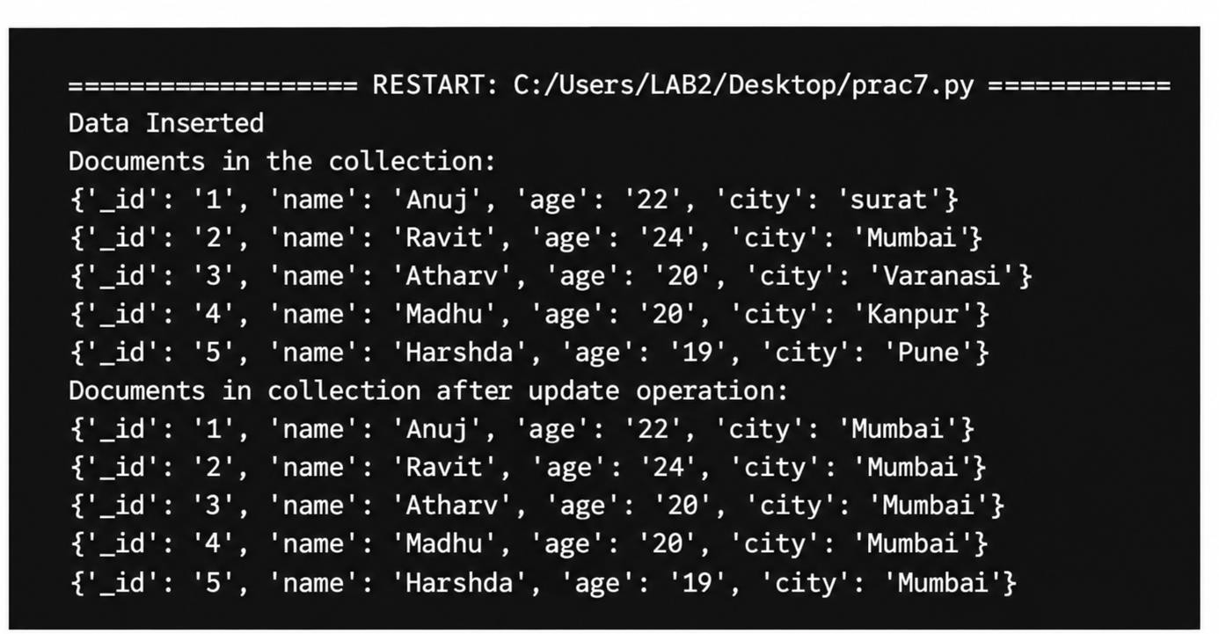
OUTPUT:

CODE:

CLASS:TYIT SEM:V ROLL NO.:TYIT36 DATE:11/09/26 COURSE NAME: NGT PAGE NO.:
PRACTICAL NO.: 07
from pymongo import MongoClient client = MongoClient("localhost",27017) db = client["AnujTYIT_27"]
coll = db[" AnujTYIT_27"]
data =[{"_id":"1","name":"Anuj","age":"22","city":"surat"},
{"_id":"2","name":"Ravit","age":"24","city":"Mumbai"},
{"_id":"3","name":"Atharv","age":"20","city":"Varanasi"},
{"_id":"4","name":"Madhu","age":"20","city":"Kanpur"},
{"_id":"5","name":"Harshda","age":"19","city":"Pune"}] res= coll.insert_many(data)
print("Data Inserted") print(res.inserted_ids) coll.delete_one({"_id":"2"}) for doc2 in coll.find(): print(doc2)
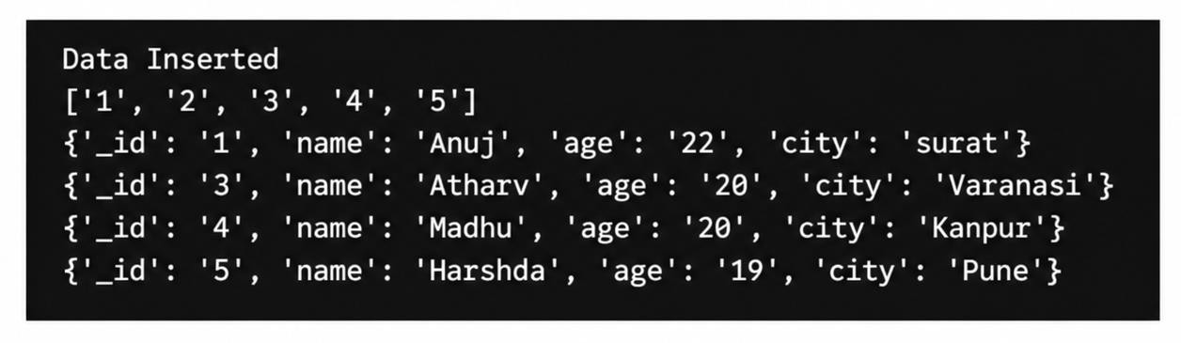
CODE:

Class: TYIT(NEP) Sem: V Roll No.: TYIT36 Date: 13/08/2026
Course Name: Next Generation Technologies (NGT) Page no: Practical Number:- 08
AIM: Implement Programs On Basic Jquery.
Code:

- Javascript

<!DOCTYPE html>
<html lang="en">
<head>
<meta charset="UTF-8">
<meta name="viewport" content="width=device-width, initial-scale=1.0">
<title>Using JavaScript</title>
</head>

<body>
<button id="button1" > Deposit
</button>

<button id="button2;"> Withdraw
</button>

<script type="text/javascript">
let btn1 = document.getElementById("button1"); let btn2 = document.getElementById("button2"); btn1.addEventListener("click", () => {
alert("Anuj , you have successfully deposited the amount.");
});

Class: TYIT(NEP) Sem: V Roll No.: TYIT36 Date: 13/08/2026
Course Name: Next Generation Technologies (NGT) Page no:
Practical Number:- 08
btn2.addEventListener("click", () => {
alert("Anuj, you have successfully withdrawn the amount.");
});

</script>
</body>
</html>

OUTPUT:
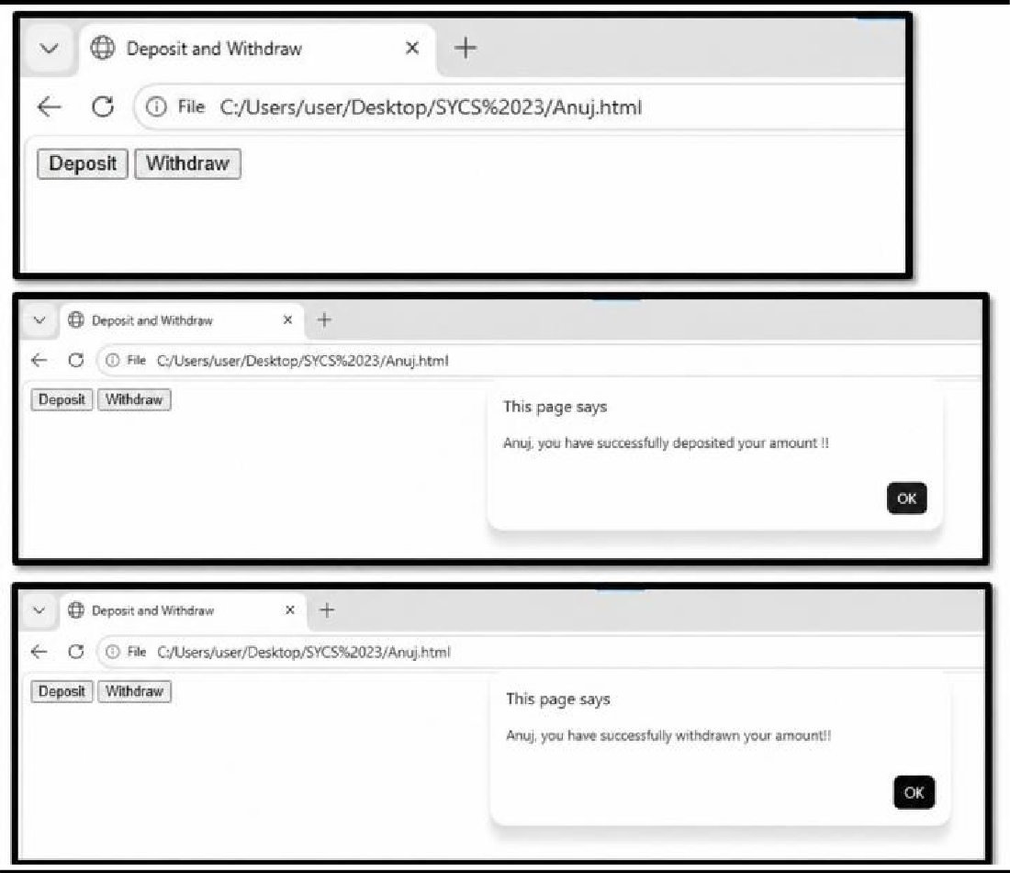

Class: TYIT(NEP) Sem: V Roll No.: TYIT36 Date: 13/08/2026
Course Name: Next Generation Technologies (NGT) Page no: Practical Number:- 08

JQUERY
<!DOCTYPE html>
<html lang="en">

<head>
<meta charset="UTF-8">
<meta name="viewport" content="width=device-width, initial-scale=1.0">
<script src="https://code.jquery.com/jquery-3.7.1.js"></script>

<title>Deposit and Withdraw</title>

</head>

<body>

<h2>Rooshda, please select an option:</h2>
<button id="Withdraw" style="padding: 12px 30px; font-size: 16px;"> Withdraw
</button>

<button id="Deposit" style="padding: 12px 30px; font-size: 16px;"> Deposit
</button>

<script type="text/javascript">

$(document).ready(function() {
$("#Withdraw").click(function() {

alert("Anuj, you have successfully withdrawn the amount using jQuery.");

});

$("#Deposit").click(function() {

Class: TYIT(NEP) Sem: V Roll No.: TYIT36 Date: 13/08/2026
Course Name: Next Generation Technologies (NGT) Page no:
Practical Number:- 08
alert("Anuj, you have successfully deposited the amount using jQuery.");
});
});

</script>
</body>
</html>

OUTPUT
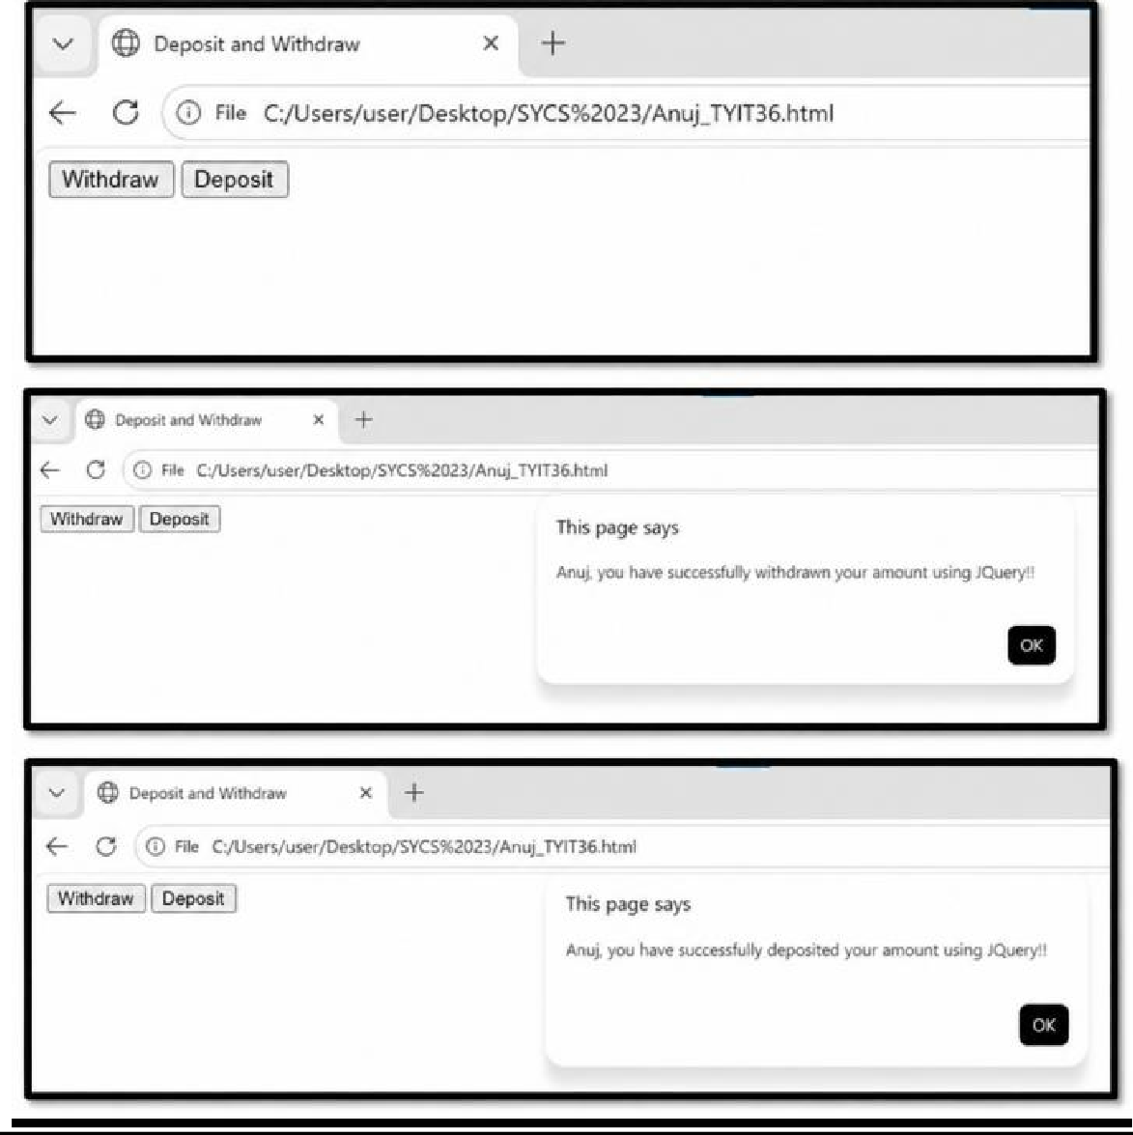
:

Class: TYIT Sem: V Roll No.: TYIT36 Date:14/08/2026 Course Name: NEXT GENERATION TECHNOLOGIES (MAJOR – II) Page no:
BHAVAN’S COLLEGE AUTONOMOUS, ANDHERI-WEST
PRACTICAL JOURNAL
Practical Number: - 09
AIM: Implement JQuery. Code:
<!DOCTYPE html>
<html lang="en">
<head>
<title>Anuj.</title>
<script src="https://code.jquery.com/jquery-3.7.1.js"></script>
</head>
<body>
<h2>TYIT36 Anuj</h2>
<p>This is Anuj</p>

<script type="text/javascript">
$("document").ready(function() {
$("p").click(function() {
$(this).hide();
});
});
</script>
</body>
</html>

Output:
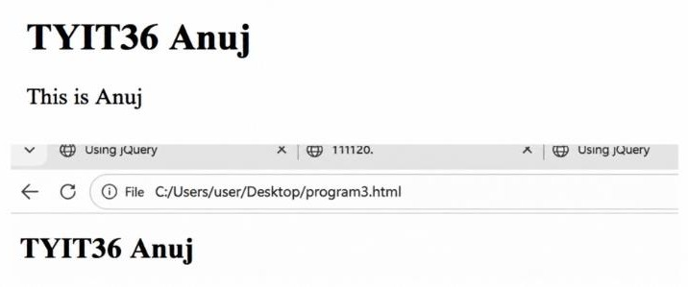

CLASS:TYIT SEM:V ROLL NO.:TYIT36 DATE:21/08/2026 COURSE NAME: NGT PAGE NO.:
PRACTICAL NO.:10

AIM: Implement JQuery Events.

- fadeTo - fadeTo() is a jQuery effect used to change an element's opacity gradually to a specified value. It can make an element partially or fully transparent while keeping it visible. Code:
<!DOCTYPE html>
<html lang="en">
<head>
<meta charset="UTF-8">
<meta name="viewport" content="width=device-width, initial-scale=1.0">
<title>Next Generation Technology</title>
<script src="https://code.jquery.com/jquery-3.7.1.js"></script>
</head>
<body>
<p>Bhavans College Anuj TYIT36</p>
<button>Click here</button><br><br>
<div id="div1" style="width: 2000px; height: 150px; background-color: orange;"></div>
<div id="div2" style="width: 2000px; height: 150px; background-color: white;"></div> <div id="div3" style="width: 2000px; height: 150px; background-color: blue;"></div>
<div id="div4" style="width: 2000px; height: 150px; background-color: green;"></div>
<script>
$(document).ready(function() {
$("button").click(function (){
$("#div1").fadeTo("slow", 0.15);
$("#div2").fadeTo("slow", 0.4);
$("#div3").fadeTo("slow", 0.7);
$("#div4").fadeTo("slow", 0.7);
});
});
</script>
</body>
</html>

CLASS:TYIT SEM:V ROLL NO.:TYIT36 DATE:21/08/2026 COURSE NAME: NGT PAGE NO.:
PRACTICAL NO.:10

OUTPUT:
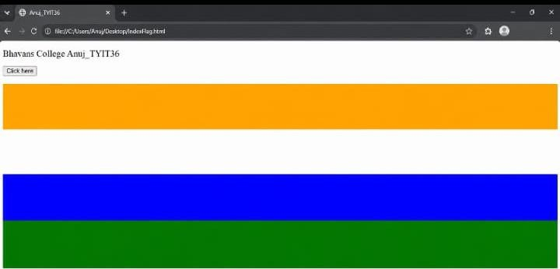
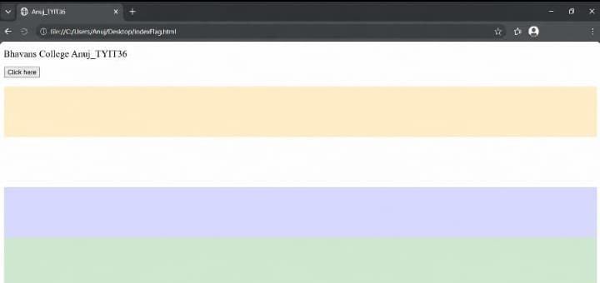

CLASS:TYIT SEM:V ROLL NO.:TYIT36 DATE:21/08/2026 COURSE NAME: NGT PAGE NO.:
PRACTICAL NO.:10

- slideDown - slideDown() is a jQuery effect used to show a hidden element by sliding it downward. It gradually increases the element's height until the complete content is visible.

Code:

<!DOCTYPE html>
<html lang="en">
<head>
<meta charset="UTF-8">
<meta name="viewport" content="width=device-width, initial-scale=1.0">
<title>Next Generation Technology</title>
<script src="https://code.jquery.com/jquery-3.7.1.js"></script>
<style>
#panel, #flip{ padding:
5px; align-items: center; background-color: #e5eecc; border: solid 1px #c3c3c3;
}
#panel{ padding:
5px; display:
none;
}
</style> </head>
<body>

<div id="flip">What is your favourite Cars Anuj?</div>

<div id="panel"> Porsche<br> McLaren <br> BMW<br>
Lamborghini <br>
</div>

<script>
$(document).ready(function() {
$("#flip").click(function () {
$("#panel").slideDown("slow");
});
});
</script>
</body>
</html>

CLASS:TYIT SEM:V ROLL NO.:TYIT36 DATE:21/08/2026 COURSE NAME: NGT PAGE NO.:
PRACTICAL NO.:10
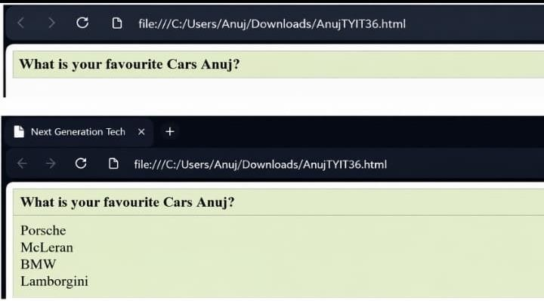
OUTPUT:

